dgerterergergg

**ASSIGNMENT DOCUMENTATION**

**ON AWS COGNITO**

**Dated- 09-12-2022**

**By- Ritesh**

What is Amazon Cognito?

Amazon Cognito provides authentication, authorization, and user management for your web and mobile apps. Your users can sign in directly with a username and password.

* The two main components of Amazon Cognito are user pools and identity pools.
* User pools are user directories that provide sign-up and sign-in options for your app users. Identity pools enable you to grant your users access to other Amazon services.

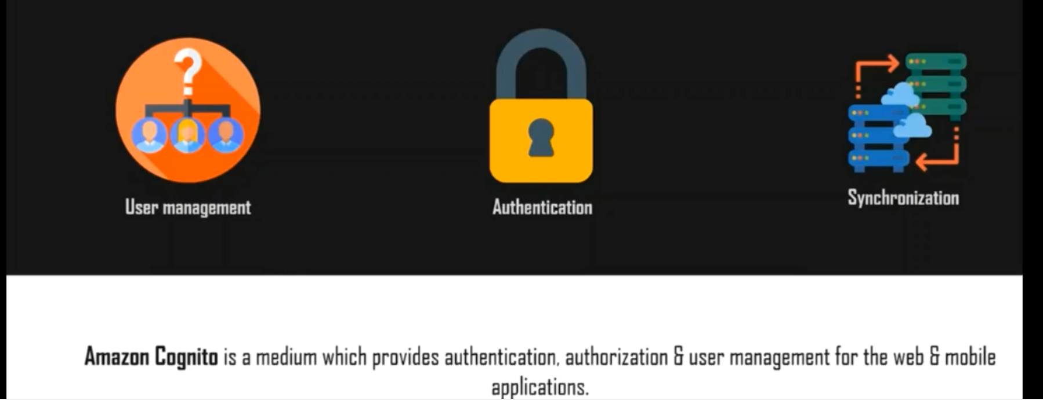

**Features-**

**Sign-in with identity providers**

Cognito supports sign-in with social identity providers, such as Apple, Facebook, Google, and Amazon, and enterprise identity providers via SAML 2.0 and OpenID Connect.

**User storage**

Cognito can store up to 40 million users! And thanks to the AWS pay-as-you-go approach for pricing, you only pay for users that sign in each month.

There’s also a free tier that includes the first 50,000 users signed in using User Pool credentials or social identity providers.

This means that a lot of small apps, and apps that are in development, won’t even leave the free tier!

**Advanced security features**

Cognito has security features that protect your users and their accounts from danger.

Cognito can automatically detect unusual sign-in activity, such as sign-in attempts from new locations and devices. It assigns a risk score to the activity and lets you choose to either prompt users for additional verification or straight-up block the sign-in request. It can also notify users of suspicious login attempts.

Cognito can also detect credentials that were compromised, prompting users to change their passwords.

**Messaging**

Cognito can send email messages to verify user email addresses, telling them that they’ve been invited and notifying them of suspicious sign-in attempts to their accounts.

Cognito also sends SMS messages used for Multi-Factor Authentication.

**In-built UI**

Cognito has an in-built, customizable UI that can be used by users  to sign up and sign in. This allows you to quickly develop a basic application or even skip the process of building those elements altogether.

**Custom triggers**

Cognito allows you to make advanced customization using AWS Lambda functions. For example, you can have your Lambda trigger when a user tries to sign-up to perform some custom validation and accept or deny the sign-up request. More on that later

**How It Works**

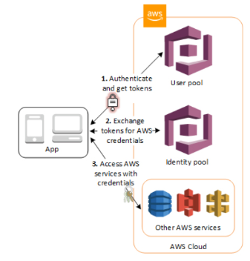

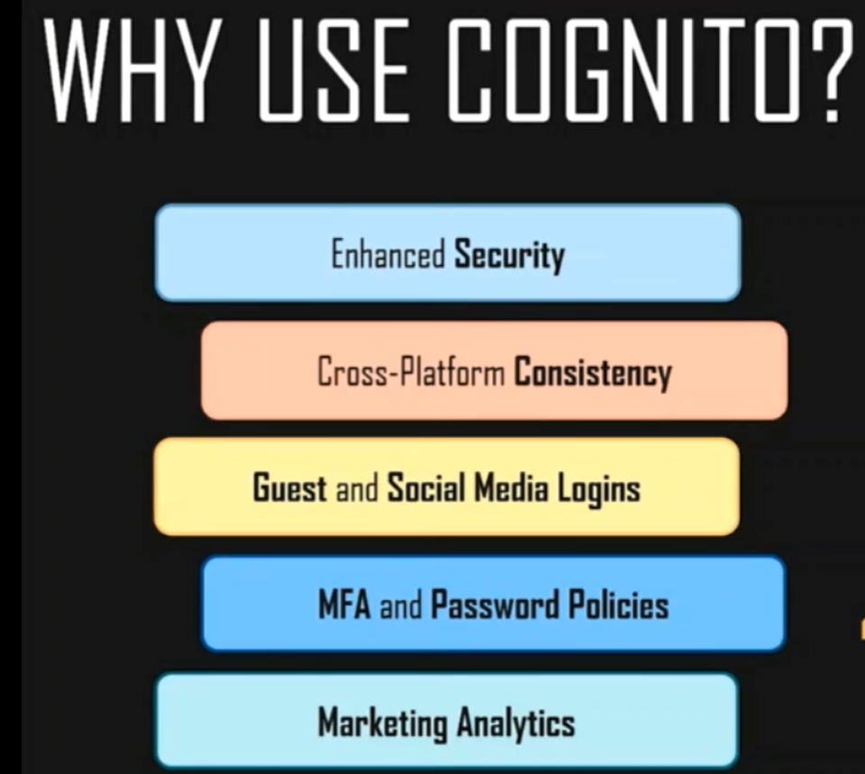

**User Pools:-**

* User pools are user directories that provide sign-up and sign-in options for your app users.
* Users can sign in to your web or mobile app through Amazon Cognito, or federate through a third-party identity provider (IdP).
* You can use the aliasing feature to enable your users to sign up or sign in with an email address and a password or a phone number and a password.
* User pools are each created in one AWS Region, and they store the user profile data only in that region. You can also send user data to a different AWS Region.
* A User Pool is like a directory of users.

